|  |  |  |  |
| --- | --- | --- | --- |
| **Document title** | GS402A0068 Measuring System Qualification (MSQ) and Measuring System Documentation (MSD) | | |
| **Document Type** | Standard | **Valid from** | 17-May-2024 |
| **Author** | GMAIZU | **Owner** | GBJBKG |
| If this is a printed version (copy), the original can be found in IMS/QMS/SC via Insite/Toolbox. | | | |

***Document history***

|  |  |
| --- | --- |
| ***Version*** | ***Changes from last revision and why*** |
| *8.0* | *New standard owner*  *Section 2.0 - Type 1 “Repeatability and Bias approval”: New department name*  *Section 4.1.1 Performing the MSQ – Solara for type 0 analysis removed* |

# Purpose

The purpose of this Grundfos Group Standard is to lay down rules for verification of measuring equipment.

**Measuring System Qualification “MSQ”**

* To ensure a sufficient measuring accuracy of relevant measuring systems producing continuous data.
* To state the requirements and responsibilities in connection with approval of equipment according to MSQ.
* To define when a MSQ shall be conducted.

**Note:** MSA is a subprocess of MSQ.

**Measuring System Documentation “MSD”**

* To ensure the necessary documentation for the relevant measuring systems.
* To state the requirements and responsibilities for MSD.

# Scope

**This Group Standard applies to:**

* all measuring systems producing continuous data used for production verification of specifications or function.
* all measuring systems producing continuous data used for production process verification.

Key geometric measuring equipment is not covered by this standard, see GS400A0001.

**This Group Standard shall be applied:**

* in connection with approval of new measuring equipment or a new measuring process from internal or external suppliers.
* in connection with process change, redesign, repair, maintenance, or shipment of equipment - if the actions might have negative consequences for the validity of the original system qualification.

Lending of measuring equipment to external supplier is covered by GS400A0001.

**Conditions:**

The purpose of carrying out a MSQ is to evaluate the equipment's capability of measuring correctly under the influence of the conditions that might affect the measuring accuracy, so

* manual measuring equipment/setups or automatic/integrated measuring process/system shall be calibrated before the MSA test.
* the study shall be carried out under conditions similar to the production conditions. The start-up stage shall for example be completed, and the equipment/process shall work stable.
* the equipment shall be operated by trained operators.
* items from the production line or from conditions similar to those for the current production shall be applied for the study. When possible, the items should cover the entire variation range of the process.
* adjustment or master setting (master ring, zero settings, etc.) of the measuring equipment is not allowed during the study except if it is a natural part of the measuring procedure, e.g. cleaning of the equipment is acceptable, dismantling is not.
* as concern motor testers for final testing, it shall be agreed between seller and buyer how to carry out the MSA test

**Measuring System Analysis (MSA)**

**Type 1 “Repeatability and Bias approval”:**

* For pre-approval of new measuring equipment or of a new measuring process “except”.
  + Final approval of CMM, optical measuring machines, form testers, test beds, testers of electronic products and leak testers without operator influence where a “reference value” is not available. This means that Type 2, Type 3 and Type 0 shall not be performed.
* Before transfer of measuring equipment between factories/plants (within 3 months before transfer).
* After reception of equipment - if either the equipment or its packaging shows any sign of damage - a reduced test can be performed.
* After reception of equipment that has been shipped between factories/plants - a reduced test can be performed.
* As part of periodic maintenance of the measuring equipment minimum every two years.
* Whenever measuring equipment has been damaged, a test can be performed with a reduced number of measurements.
* Regarding CMM, optical measuring machines, form testers – whenever new part/fixture has been added to the system or after changes on existing part geometry (that influence measuring principles or measuring program characteristic), or after changes of fixture design (that has influence on measuring principle) MSA test should be conducted/repeated. It is not necessary to repeat MSA test, if only small changes in measuring programs has been made (f. ex. change of tolerance value or other small changes of measuring characteristic). Due to complexity and infinity number of possible changes that can be made, it is not possible to describe them all and in unclear situations AME Measuring lab can provide further clarification.

**Type 2 “Repeatability and Reproducibility approval”:**

**Note:** Type 2 test is equal with the Gage R&R.

* For final approval of new measuring equipment or of a new measuring process where the measuring results from the measuring system are influenced by operators.
* Before transfer of measuring equipment between factories/plants, a MSA Type 2 test shall be available – no specific requirement when type 2 has been conducted.

**Measuring System Analysis (MSA) Type 3 “Repeatability and Reproducibility approval”:**

**Note:** The type 3 test is equal with the Gage R&R.

* For final approval of new automatic or integrated measuring process or system where the results from the measuring equipment are **not** influenced by operators.
* Before transfer of measuring equipment between factories/plants, a MSA Type 3 test shall be available – no specific requirement when type 3 has been conducted.

**Type 0 “D**uality”**:**

Type 0 shall only be used whenever the principle of duality according to GPS (Geometrical Product Specification) is not kept during the verification.

* Type 0 shall only be used whenever a difference occurs between the part drawing specification operator and the control instruction verification operator.

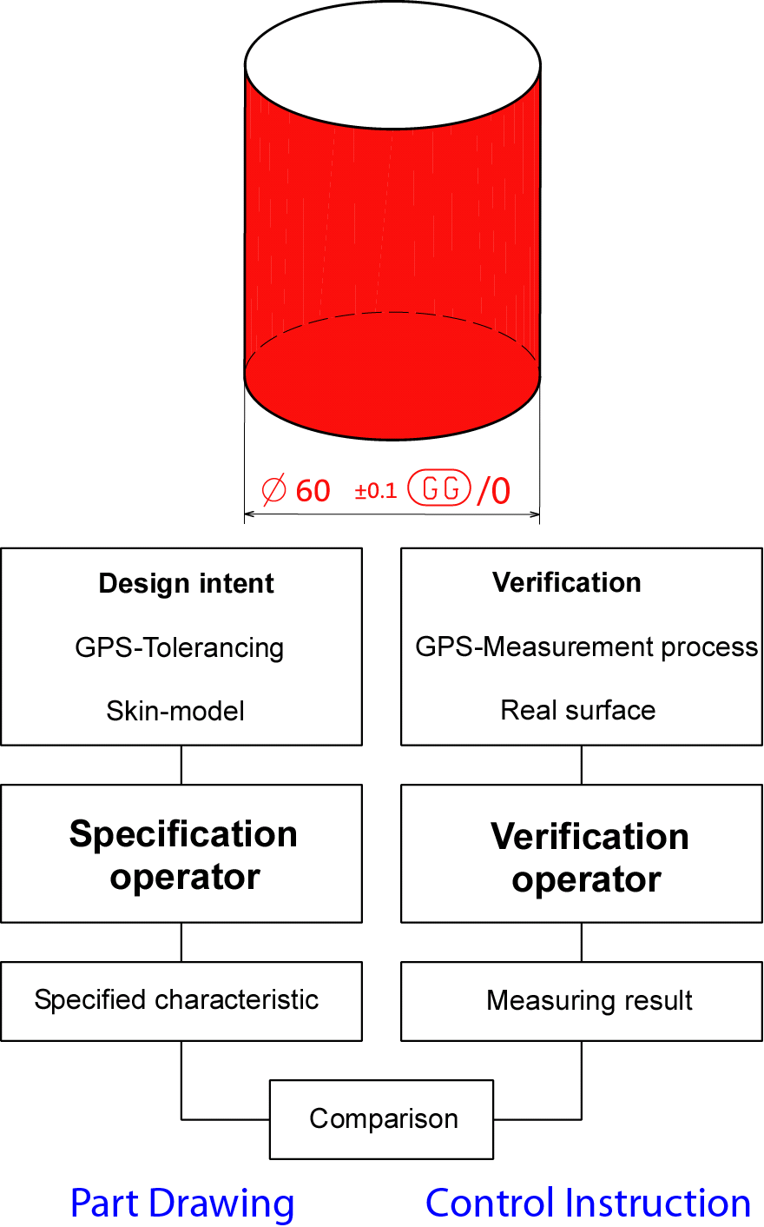

# Responsibilities

|  |  |
| --- | --- |
| **New or existing measuring equipment in connection with:** | **Responsibility** |
| Development projects | Equipment Project Manager |
| Production | Plant Manager |
| Lending of measuring equipment to external suppliers | In accordance with GS400A0001 |
| Suppliers' measuring equipment | Purchasing Manager – in accordance with GS402A0009 and GS402A0006 |
| Documentation of new equipment | Supplier of the equipment |
| Documentation of existing equipment | Plant Manager |

Before conducting a Measuring System Analysis, it shall be ensured that the personnel who are supposed to carry out the analysis and make the subsequent analysis are qualified, i.e. that they have the required knowledge of MSA and of the equipment concerned.

# Requirements

**4.1 Requirements for the MSQ**

**4.1.1 Performing the MSQ**

The MSQ consists of several individual Measuring System Analyses (MSA).

The individual MSAs shall be performed as described in the MSQ Group procedure.

* The program Solara from the company Q-DAS GmbH is the standard system used by Grundfos for the handling of Measuring System Analyses.
  + Cg and Cgk (MSA Type 1) shall be calculated according to the MSQ Group Procedure.
  + MSA Type 2 and Type 3 (Gauge R&R) shall be calculated according to the MSQ Group Procedure.
  + Type 0 analyses shall be made in a excel spreadsheet.

**Flow diagram for MSA type 1, 2, and 3**



**4.1.2 MSA test requirements**

**The following requirements apply:**

All measuring system capability requirements relate to the corresponding product specifications/tolerance as stated on the Control Instruction and - if no Control Instruction exists - to the corresponding Part Drawing.

All requirements are minimum requirements.

|  |  |
| --- | --- |
|  | **MSA Type 1** |
| **The resolution < 5% of the tolerance** | The equipment can be accepted as regards the resolution.  **Example:** Nominal value = 25,1 ±0,1 mm.  The resolution shall be less than 5% of 0,2 mm, i.e. < 0,01 mm. |
| **1 part measured 30 times**  **Cg and Cgk > 6,67** | The equipment can be accepted.  **Exemption:** For CMM, form testers, test bed and leak testers without operator influence, a Type 1 test can be performed with a reduced number of tests.  The project manger/project team must agree upon the reduced number of tests.  **Exemption:** For test bed and testers for electronic products, the MSA study is only performed on a Type 1 test (Cg), i.e. the Cgk value is neither calculated nor required. |
| **If Cg and Cgk are smaller than 6,67 but larger than or equal to 3,33** | The mechanical equipment can be approved if the tolerances < 0,02 mm.  **Exemption:** The equipment can be approved as regards a Type 1 test if the Product Technical Manager and the receiving department/plant accept the obtained Cg and Cgk values.  Acceptance shall be documented in the MSD. |
| **If Cg and Cgk are smaller**  **than 3,33** | The equipment cannot be approved.  **Exemption: Electronic equipment where the DUT is the measuring system.** |

|  |  |
| --- | --- |
| **MSA Type 2 and Type 3** | |
| **Type 2 (Gage R&R):**   * + - **5 parts measured**     - **4 times each by**     - **3 operators**   **Type 3 (Gage R&R):**   * **20 parts measured** * **2 times each** | **Type 2:**  Operators shall be selected from the group of people using the measuring system in the daily production.  **Type 3:**  For final approval of new automatic or integrated measuring process or system. |
| **Gage R&R < 15%** | The equipment can be approved. |
| **15% < Gage R&R < 30%** | The mechanical equipment can be approved if the tolerances < 0,02 mm.  **Exemption:** For measurement uncertainty 15% < Gage R&R < 30%, the Product Technical Manager and the receiving department/plant can accept the measurement uncertainty.  Acceptance shall be documented in the MSD. |
| **Gage R&R > 30%** | The equipment cannot be approved. |

|  |  |
| --- | --- |
| **MSA Type 0** | |
| **Minimum 5 parts shall be tested** | The parts shall be representative for the production variation at the DP5.  All parts shall fulfill the requirements. |
| **MSA Type 0 < 15% of the tolerance.** | The equipment can be approved. |
| **15% < MSA Type 0 < 30% of the tolerance** | **Exemption:** Product Technical Manager and the receiving department/plant can accept the Type 0 result.  Acceptance shall be documented in the MSD. |
| **30% < MSA Type 0 result** | The equipment cannot be approved. |

**4.2 Requirements for Measuring System Documentation (MSD)**

All relevant measuring system documentation, i.e. MSA tests, calibration data, design guide, maintenance plans, etc shall be saved under the measuring equipment number i.e. SAP PM module or other relevant databases.

MSD is obligatory for equipment approved after January 2010.

# Definitions

MSQ Measuring System Qualification

MSD Measuring System Documentation

MSA Measuring System Analysis

Gage R&R Repeatability & Reproducibility

GPS Geometrical Product Specification

Duality Comparison between specification operator and verification operator

Solara Statistical Software program

Bias Difference between the average of measurements made on the same part and its true value

CMM Coordinate Measuring Machine

# Records

|  |  |  |  |
| --- | --- | --- | --- |
| **Type of record** | **Where** | **How long** | **Responsible** |
| **Solara MSA test report** | Measuring equipment data (X / V drive)  For GBJ: X:\DK\bje\Proj\NCMUPKAP | Throughout lifetime | Person responsible for the study |

# References

|  |  |
| --- | --- |
| **Document Number** | **Document Title** |
| **GS241A0540** | Test beds and test equipment |
| **GS318A0001** | Technical drawing – Classification of requirements on drawings |
| **GS400A0001** | Measuring tools - Ordering, maintenance, calibration and lending |
| **GS402A0006** | Sample certificate VPC - Instructions in application |
| **GS402A0009** | Supplier Approval |
| **GS402A0046** | Capability study – Machines and tools |
| **GS402A0049** | Process FMEA |
| **GS402A0050** | Definition and calculation of control limits |
| **ISO GPS** | Matrix of standards |
|  | Grundfos’ Product Development Process (on INSITE) |
| **GRI.LITT. 15471** | Facts about Capability Studies Terms and calculation methods are defined in GRI.LITT. 15471 "Facts about Capability Studies" |
| **GP402A0068-01** | Procedure for Measuring System Qualification (MSQ) |
| **GP402A0068-02** | Measuring System Analysis (MSA) for pump testbeds |