|  |  |  |  |
| --- | --- | --- | --- |
| **Document title** | GS402A0046 Capability study - Machines, tools and measuring equipment | | |
| **Document Type** | Grundfos Standard | **Valid from** | 08-Oct-2024 |
| **Author** | GMATKR | **Owner** | GMHLAKL |
| If this is a printed version (copy), the original can be foundin IMS/QMS/SC via Insite/Toolbox. | | | |

***Document history***

|  |  |
| --- | --- |
| *Version* | *Changes from the last revision and why* |
| *7.0* | *Owner, template and references have been updated. Updates in GS318A0001 is now refelected in the standard* |

# Purpose

This standard describes when and how to perform capability studies on production equipment used in suppliers' production facilities as well as in Grundfos' own production facilities and lays down requirements for the capability.

Capability studies are a statistical tool that can give a survey of processes which are capable, and processes which need to be optimized.

By the aid of the process capability index it is possible to determine the inspection frequency based on statistics and thus to ensure production with zero failure.

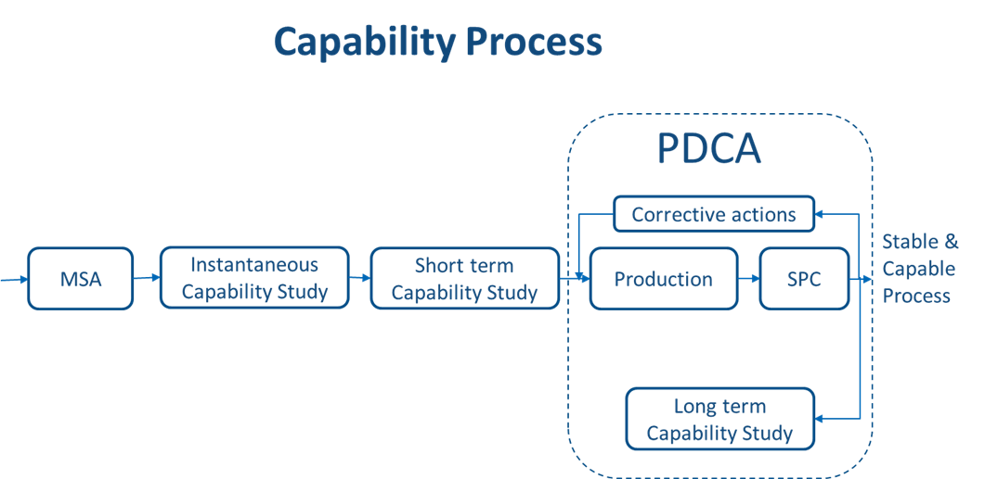

*Figure 1*

# Scope

**The standard applies to:**

* Grundfos produced and purchased components with requirements classified according to GS318A0001 (class "0" requirements,SCC, [2], [2F] [2P], [-D]) if the below conditions are fulfilled:
* The measurements shall be collected as variable data, i.e. a control measurement shall be performed with an indicating instrument.
* Inspection takes place by sampling.
* The process is not subject to 100% inspection

**Flowchart showing when capability studies are required:**

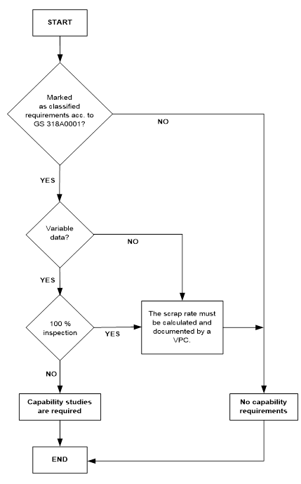

Figure 2

**The standard shall be applied:**

* In connection with approval of a new production equipment or new production processes.
* For existing production equipment or processes - when the product design has been changed substantially.
* For repaired equipment - if the repair might have influence on the product quality.
* In connection with evaluation and approval of suppliers and their processes.
* In connection with monitoring of selected processes.
* For existing items - if requirements have been classified according to GS 318A0001 after revision of the drawing.

**2.1 Requirements and Confidence interval**

|  |  |  |  |  |  |  |  |  |
| --- | --- | --- | --- | --- | --- | --- | --- | --- |
| **Capability type** | **Terms** | **Capa-**  **bility index** | **Critical capa-**  **bility**  **index** | **Require-**  **ments for Adjustable process** | **Require-**  **ments for Non adjustable process** | **QS stat module to use** | **Default**  **require-**  **ment for sample size** | **Requirements for sampling method** |
| **Machine**  capability study | **Instan-**  **taneous**  study | Cm | Cmk | Cm > 1,67  Cmk > 1,67 | Cm > 1,67  Cmk > 1,33 | Sample module | 100 items | 100 items taken in succession **or** very close succession |
| **Prelimi-**  **nary**  capability study | **Short**  **term**  study | Pp | Ppk | Pp > 1,67  Ppk > 1,67 | Pp > 1,67  Ppk > 1,33 | Process module | 100 items | 20 samples of 5 items  **or**  100 items are taken one by one evenly distributed |
| **Process**  capability study | **Long**  **term**  study | Cp | Cpk | Cp > 1,33  Cpk > 1,33 | Cp > 1,33  Cpk > 1,33 | Process module | 250 items | 50 samples of 5 items  **or**  250 items are taken one by one evenly distributed |
|  |  |  |  | Short references:  **Grade 1** | Short references:  **Grade 1** | In acc. with 4.1 | In acc. with 4.2.3, 4.3.3 or 4.4.3 | In acc. with 4.2.3, 4.3.3 or 4.4.3 |

Table 1

**Note:**

* If the requirements on the drawings or in the specification are not classified according to GS318A0001, there are no capability requirements!
* All requirements are minimum requirements.
* For one-sided tolerances, there will only be requirements for the critical capability index (Cmk, Ppk, and Cpk).

**Exemption:**

For DP projects which have passed DP3 before 2001-03-26 and for equipment ordered before 2001-03-26, the capability requirements are as follows:

|  |  |  |  |  |
| --- | --- | --- | --- | --- |
| **Machine**  capability study | **Instantaneous**  study | Cm | Cmk | Cm > 1,33  Cmk > 1,33 |
| **Preliminary**  capability study | **Short term**  study | Pp | Ppk | Pp > 1,33  Ppk > 1,33 |
| **Process**  capability study | **Long term**  study | Cp | Cpk | Cp > 1,33  Cpk > 1,00 |
|  |  |  |  | Short references:  **Grade 2** |

Table 2

**2.1.1 Confidence interval**

**Confidence interval** (also called margin of error)is the range within which the true value of an unknown parameter is likely to lie.

The statistical uncertainty depends on the sample size, i.e. by a random sample of 100, the uncertainty of a capability index of 1.33 is +0,25.

At Grundfos, we apply a mandatory 95% confidence interval for calculation of the capability.

The below graph shows the statistical uncertainty for a specific capability index and the corresponding sample.

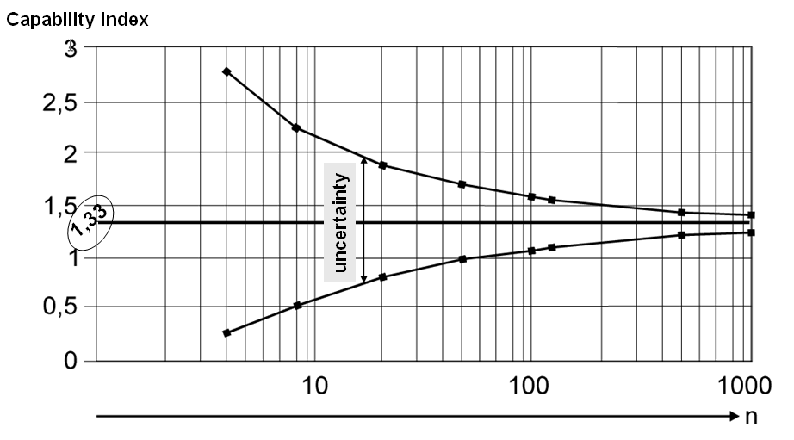

Figure 3

**2.2 Application of capability requirements on technical specifications**

On drawings and other kinds of technical specifications the requirement for capability shall be specified by adding a reference to GS402A0046 with the chosen grade in the vicinity of the drawing head as illustrated in figure 4.

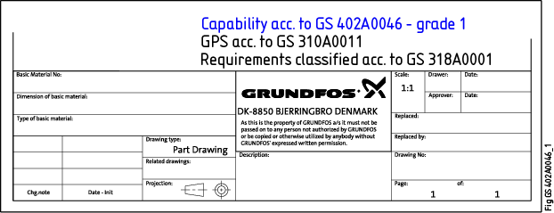

Figure 4: The figure shows how to specify on a part drawing that capability requirements grade 1 are required.

**2.3 Duplicates of old equipment**

When duplicates of old equipment are made to be applied for old items which should comply with the requirements applying at the time the items were made, it shall be ensured that the duplicate equipment as a minimum complies with these former requirements.

It shall always be considered whether it will be possible - technically as well as financially - to comply with the new and intensified requirements.

**2.4 The below studies shall be applied**

|  |  |
| --- | --- |
| **Equipment and/or parts approvals for FAT test** | A machine capability study |
| **Parts approvals VPC** | A preliminary capability study |
| **For current production** | A process capability study |

Table 3

**2.5 Special conditions and exceptions from the requirements of this standard**

**Special conditions:**

* **Capability requirements for roughness:**  
  If the roughness specification is without "max" or "min", then the 16% rule applies, i.e. 1 out of 6 measurements on the same samples may exceed the specification limit.  
  The capability requirement is Ppk > 1 and Cpk > 1.

**Exceptions from the requirements of this standard:**

* **Standard components made according to national and international standards:**   
  Purchased standard components like steel, ball bearings, O-rings etc. made according to national and international standards shall comply with the requirements of these standards.

**Envelope requirements for geometrical tolerances:**  
The capability study for envelope requirement depends on the chosen measuring strategy:

|  |  |  |
| --- | --- | --- |
| **Measuring strategy for envelope** | **Shall capability analysis be performed?** | |
| **MML** | **LML** |
| MML: GN/GX checked by plug/ring gauge  LML: LP checked by indicating measuring tool | No *2) | Yes *1) |
| MML: GN/GX checked by CMM  LML: LP checked by CMM | Yes *1) | Yes *1) |

*1) Single sided analysis

*2) Attribute testing during VPC. 100 samples shall be checked and all shall be "ok".

* **100% inspection:**   
  The capability requirements do not apply when 100% inspection is carried out.   
  Requirements is part of a statistical tolerance chain classified as <ST> then only 60% of the tolerance can be used.A preliminary capability study shall be performed in order to document the scrap rate before the final approval of the parts or of the equipment.
* **Current production of small batches:**  
  As concern current production of small batches, such as e.g. Kan Ban production, it is not always adequate or possible to measure the long term capability as the process due to many startups and closedowns does not comply with the conditions for a long term study.  
  These small batches shall instead be treated as a preliminary capability study (Pp & Ppk) with the same requirement for capability as for a process capability study (> 1,33).
* **Product lines with a low annual number of produced units:**  
  Products or components with a very low annual number of produced units, e.g. 250 per year, are not covered by this standard. In these cases 100% inspection shall be carried out on the classified requirements.

# Responsibilities

|  |  |
| --- | --- |
| **Studies in connection with** | **Responsibility** |
| Development projects | The Project Manager |
| New or existing equipment and processes | The Plant Manager |
| Purchased parts | The Category/Purchasing Manager |

Table 4

Before starting the study, it shall be ensured that the personnel who are to carry out the study and make the subsequent analysis are qualified, i.e. that the personnel have the required knowledge of capability studies and of the equipment concerned.

# Requirements

**4.1 General conditions for machine, preliminary, and process capability studies**

* Before starting the study, it shall be ensured that the measuring and production equipment has been tested and adjusted so that the processes are running without problems and are stable within the specified process window, i.e. that the operating temperature and all other conditions are similar to those applying to the ordinary production.  
  It shall be ensured that the items gathered for the study are produced under similar conditions. Startups and breaks might have a considerable influence on the items and their parameters.
* Capability studies shall be carefully planned. It shall be decided which variation sources to include in the capability study and for which process situation and period it is wanted to evaluate the capability.

Collection of data for the study shall by conducted in a manner that ensures representative data for the selected process situation and period.

* In some cases it may be practical to carry out the study on a few of the most critical dimensions only, for example a lathe tool machining several dimensions during the same working cycle, or a cast item the dimension of which depends on one mould part.
* Process parameters of importance to the product quality, e.g. cycle time, temperature,clamping force, and conditions of importance to the equipment in question, such as discharge of chips and feeding systems, shall be under control and documented.
* A **M**easurement **S**ystem **Q**ualification according to GS402A0068 shall be carried out before starting the capability study. If possible, the measuring equipment should be the same as the equipment used in connection with VPC.
* The same grade of material shall be applied during the study.
* Items which are to be used for another capability study shall comply with the tolerances and capability requirements before starting the study.
* An attribute test is a Go or No-Go test. As a main rule the sample size for a sample test shall be minimum 300 parts, and the status for all parts must be the same (Go or No-Go).
* **Adjustable processes:**   
  Are defined as processes where it is possible to adjust the geometrical dimensions in the entire tolerance zone. Examples of processes characteristic for this are turning, cutting, grinding, honing, spark machining, and rolling.
* **Non-adjustable processes:**   
  Are defined as processes where it is not possible to adjust the geometrical dimensions in the entire tolerance zone. Examples of processes of this character are punching, pressing, casting, and joining.

Unrelated, mobile, and combined tolerance zones are also defined as Non-adjustable parameters:

* unrelated tolerance zones (flatness, straightness, roundness, cylindricality, form of line and form of surface).
* mobile tolerance zones (parallelism, perpendicularity and angularity, form of line and form of surface).
* combined tolerance zones (run out and total run-out).
* The statistical uncertainties depend on the sample size and on the confidence interval (see 2.1.1 Confidence interval).

If the number of manufactured items is less than 30, there will be no basis for a capability study. Allitems shall then be measured, and they shall comply with the specifications.

**4.1.1 Capability software and flowchart for sampling and calculation of results**

**Capability software**

* qs-STAT software is mandatory in connection with the approval of products and components, while Minitab software can beused for improvement projects e.g. Six Sigma projects.
* The program qs-STAT from the company **Q-DAS GmbH** is the standard software program applied for determination of the capability indices internally at Grundfos. External suppliers may use their own software.

In cases where Grundfos specifies that the qs-STAT software shall be used, the supplier must include the raw data (measuring results) together with the samples:

* Cm and Cmk are calculated by the aid of the qs-STAT module "qs-STAT Sample analysis".
* Pp, Ppk, Cp, and Cpk are calculated by the aid of the qs-STAT module "qs-STAT Process analysis".
* If qs-STAT evaluates that the process is unstable, the indices will be named Tp and Tpk.
* **Cleaning data for outliers and erroneous measurements:**

Erroneous measurements and outliers shall be removed from the data of the study before calculating the capability.

The causes for erroneous measurements and outliers may contain valuable information for optimization of a process and should therefore always be considered.

Removal of erroneous measurements and outliers shall take place according to the below definitions and rules:

* **Definition of outliers:**

Outliers are single values categorized as outliers by the qs-STAT outlier test "Summary".

This definition does no apply if the total number of outliers constitutes 5% or more of the total amount of data analysed.

* **The number of outliers constitutes more than 5% of the data comprehended by the study:**

The values shall be considered part of the process and mustnot be removed before calculation of the capability index.   
Instead the cause of these "outlier like" values shall be examined and eliminated, if possible.

* **Definition of erroneous measurements:**

If a specific error cause can be documented for the location of single values or groups of data, these data can be considered as erroneous measurements.

* **Removal of erroneous measurements:**

Erroneous measurements that can be documented shall be removed from the data before the calculation. If the study is part of a VPC, the cause must be stated in the VPC document.

For automatical generated long term capability studies the “Hampel test” must be used to remove outliers.

**Flowchart for sampling and calculation of results**

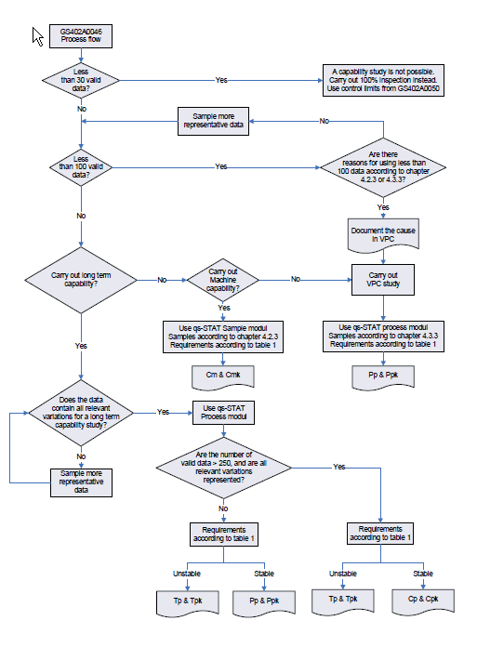

Figure 5

**4.2 Machine capability study (instantaneous study)**

**4.2.1 Purpose**

The purpose of the machine capability study is to document the capability of a tool or a machine under optimum conditions, measuring consecutive produced pieces.

Depending on the process and how well the equipment is known the machine capability study can be exchanged with a more value adding procedure, e.g. GPS630401 Procedure for run-in testing of molding tools in AME.

In cases where the optimal production conditions must be defined (e.g. heating up time or optimal machine setting), the machine capability study must be supplemented with at DOE test.

**4.2.2 Conditions**

* When it concerns multi-cavity tools or rotary tables, the items from each cavity shall be kept apart and measured and calculated separately.
* The measuring method and the measuring principle shall be documented to make it possible to reproduce the measurements.
* It is not allowed to change material batch, operator, machine, or method during the study if it might influence the result.

**4.2.3 Implementation of machine capability study**

* A test sample is taken consisting of minimum 100 items taken in succession or very close succession. All items are measured.

If it is decided to use less than 100 items, the reason shall be documented.

* As concern multi-cavity tools or rotary tables, it is acceptable just to carry out a study on one of the cavities if it can be documented, or if experience has proved that the range of variation is the same for all cavities. For cavities where no study is carried out, five items from each cavity shall be measured, and the mean value and Cm & Cmk shall be calculated from these five measurements.

The attached spreadsheet can be applied: 

As concern a multi-cavity tool or a rotary table where it is impossible to separate the cavities, such as for example for injection moulding of O-rings or stamp parts, a representative sample shall be taken. It shall be ensured that all cavities are represented or that there is a 95% probability that they are included in the sample.

* As concern non-adjustable parameters or properties - such as for example injection moulding where the variation range of the process has been documented or is known by experience - it is acceptable to calculate the capability based on a sample of only 30 items provided that Cm > 3. Correspondingly it is acceptable to interrupt a capability study if the calculated capability Cm < 1 when based on at least 30 items.
* Smaller samples are acceptable in special cases, e.g. if the batch size is very small. At least 30 items shall be taken, however, as otherwise the uncertainty of the statistical calculations will be unacceptably high.

**4.2.4 Requirements for the result**

* In accordance with table 1 or table 2.
* If the machine capability has not been obtained, an action plan shall be prepared describing the activities to be implemented to ensure compliance with the requirements.
* A preliminary process capability study for the VPC shall not be implemented till it has been documented that the machine capability complies with the requirements.

**4.3 Preliminary capability study (short term study)**

**4.3.1 Purpose**

The purpose of preliminary process capability study is to predict the capability of a process to produce items complying with the specifications during current production.

The study shall be applied for VPC treatment - from suppliers' as well as from own processes - before start of production or as a short term study during the ongoing production.

**4.3.2 Conditions**

* When it concerns multi-cavity tools or rotary tables, items from each cavity shall be kept apart and measured and calculated separately.
* The measuring method and the measuring principle shall be documented to make it possible to reproduce the measurements.
* It is not allowed to change machine or method during the study, however, if it might influence the result, it shall be decided whether to change operator or material.

**4.3.3 Implementation of the study**

* The manufacturing period for items to be used for the capability study shall have a duration ensuring that the relevant sources of variation, such as e.g. material and shift of operator will influence the natural process variation. At least 300 items should be manufactured, however.

From the study production a minimum of 100 items must be sampled - evenly distributed over the production period - and measured.

If less than 100 items are sampled, the reason shall be documented in the VPC.

**Small batch sizes:**

All items from small batch sizes of less than 100 items shall be part of the study.

If less than the required 100 items are measured, the reason shall be documented in the VPC.

* **Sampling:**

To evaluate the stability of the process, the samples shall be taken in one of the below ways:

* 20 samples of 5 items each are taken evenly distributed over the study period.
* The 100 items are taken one by one evenly distributed over the period of study with a suitable interval between the items. The moving sample shall be calculated for three items at the time in qs-STAT.
* For multi-cavity tools or rotary tables, it is acceptable to carry out a study on one of the cavities only if it can be documented or if experience has proved that the range of variation of the process is the same for all cavities. As concern the cavities on which no study is carried out, five items from each cavity shall be measured and the mean values and Pp/Ppk shall be calculated based on the five measurements.

A special spreadsheet is applied for the calculation, see attachment insection 4.2.3 Implementation of the study.

If it concerns a multi-cavity tool or a rotary table where it is impossible to separate the cavities, such as for example for injection moulding of O-rings, a representative sample shall be taken from the 0 series. It shall be ensured that all cavities are represented or that there is a 95% probability that they are included in the sample. At least 100 items shall be gathered.

* As concern non-adjustable parameters/properties where the range of variation of the process has been documented or is known by experience, it is acceptable to measure only 30 items if Pp > 3. It is also acceptable to interrupt the capability study if the calculated capability Pp < 1 based on at least 30 items.
* Smaller samples can be applied in special cases, e.g. if the serial size is very small. At least 30 items shall be taken, however, as otherwise the uncertainty of the statistical calculations will be unacceptably high.

**4.3.4 Requirements for the result**

* In accordance with table 1 or table 2.
* If the preliminary process capability has not been obtained, an action plan shall be prepared describing the activities to be implemented to ensure compliance with the requirements.
* If Ppk< 1,33, 100% inspection shall be carried out or, alternatively, the inspection frequency shall be considerably increased to ensure that the requirements are always met.
* Tightened surveillance shall be kept, till it has been documented that Ppk > 1,33.
* The requirements for Tp and Tpk are the same as those for Pp and Ppk.

**4.4 Process capability study**

**4.4.1 Purpose**

The purpose of a process capability study is to document the ability of the final production process to produce items complying with the specifications during current mass production.

The obtained capability index can be applied as a control parameter for the continuous process monitoring and as an indicator in connection with preventive maintenance.

**4.4.2 Conditions**

* The study shall comprise a minimum of 250 items. The sample shall be taken from a batch of at least 1000 items.

If the requirement for the number of items cannot be fulfilled during normal production, a short term study shall be performed instead according to "Production of small batches" in section 2.5.

* The process shall only be affected by random variation sources. Systematic variation sources are acceptable if they are known and if they are a predictable part of the natural variation of the process.
* Items from each machine, tool, multi-cavity tools or rotary tables shall be kept apart, if possible.
* Process changes that might influence the result are not allowed during the study.
* The measuring method and principle shall be documented to make it possible to reproduce the measurements.

**4.4.3 Implementation of the study**

* The duration of the study shall be at least 20 working days spread over all shifts.

To evaluate the process stability, the sample shall be taken using one of the below sampling methods:

* **Fixed sampling:**

50 samples of 5 items each shall be taken evenly distributed over the study period.

* **Moving sampling:**

The 250 items shall be taken one by one with suitable intervals between the items and evenly distributed over the study period.

The moving sample shall be calculated in qs-STAT on 3 items at the time.

**4.4.4 Requirements for the result**

* In accordance with table 1 or table 2.
* If the process capability is not obtained, an action plan shall be prepared describing activities to be implemented to ensure compliance with the requirements.
* If Cpk< 1,33, 100% inspection shall be carried out or, alternatively, the inspection frequency shall be considerably increased to ensure that the requirements are always met. Tightened surveillance shall be kept till it has been documented that the process capability is stable during current production and that Cpk>1,33.
* The requirements for Tp and Tpk are the same as those for Cp and Cpk .

**4.4.5 Running process control and monitoring**

When the capability studies have been carried out, running process control and monitoring can take place by monitoring of single values or statistical process control (SPC).

See **GS402A0050** concerning calculation and determination of control limits.

For classified requirements where documentation is mandatory (such as (SCC, [2FD], and [2PD]), the optimum of the below four monitoring concepts shall be chosen.

* A long-term study on Cp & Cpk values and documentation of the result, **or**
* 100% inspection and documentation of the result, **or**
* process surveillance using control limits and documentation of the result, **or**
* performance of periodic short-term capability studies and documentation of the result.

The results of the chosen monitoring shall be available.

**4.5 Application of the results of the study**

If the studies indicate that the requirements for the capability Cmk, Ppk, or Cpk have not been fulfilled, the influence of the following five parameters must be analysed, templates for Practical Problem Solving (PPS), Factor-Tree-Analyse (FTA) or Design-Of-Experiment (DOE) can be used:

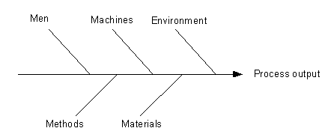

Figure 6

**Man, e.g.:** - lack of training.

**Machines and tools, e.g.:** - lack of capacity

- lack of stability

- worn-out machinery or tools.

**Environment, e.g.:** - temperature

- air humidity

- EMC (Electromagnetic Compatibility)

- vibration.

**Method, e.g.:** - unstable fixation

- insufficient instructions - oral or written

- unsuitable method.

**Materials, e.g.:** - big difference between the batches

- large variations in each batch.

A new study shall be carried out when the necessary corrections have been made.

# Definitions

|  |  |
| --- | --- |
| **Cm** | Machine capability index |
| **Cmk** | Critical machine capability index |
|  |  |
| **Pp** | Preliminary capability index |
| **Ppk** | Critical preliminary capability index |
|  |  |
| **Cp** | Process capability index |
| **Cpk** | Critical process capability index |
|  |  |
| **Tp** | Capability index - unstable process |
| **Tpk** | Critical capability index - unstable process |
|  |  |
| **MML** | Maximum Material Limit |
| **LML** | Least Material Limit |
|  |  |
| **MSQ** | **M**easurement **S**ystem **Q**ualification according to GS402A0068 |
| **MSA** | **M**easurement **S**ystem **A**nalysis |
| **SPC** | **S**tatistical **P**rocess **C**ontrol according to GS402A0050 |
| **[2F] [2P]**  **SCC** | Requirements classified according to GS318A0001  **S**afety **C**ritical **C**haracteristic according to GS318A0001 |
|  |  |
| **Main factor** | A process parameter or influence factor that can contribute more than 30% of the process variation or move the average more than 10% |
|  |  |
| **DOE** | **D**esign-**O**f-**E**xperiment is a method for testing the influencing factors of the process |
|  |  |
| **FAT** | **F**actory **A**cceptance **T**est – test of equipment or tools before they are shipped to the production site. |

# Records

|  |  |  |  |
| --- | --- | --- | --- |
| Type of record | Where | How long | Responsible |
| Data from capability studies | Q-DAS, VPC database, Design record or other relevant location for the specific study | 5 years | The person for conducting the study |
| Data sampled as part of mandatory documentation | Q-DAS | 5 years | Plant Manager |

# References

|  |  |
| --- | --- |
| **Document Number** | **Document Title** |
| GS318A0001 | Technical documents/drawing - Classification of requirements |
| GS402A0006 | VPC – Verification of Product & Process Conformance |
| GS401D0002 | Sampling plan |
| GS402A0050 | Statistical Process Control |
| GI402A0050-01 | Calculation of control limits |
| GS 402A0068 | Measuring System Qualification (MSQ) and Documentation (MSD) |
| GPS630401 | Procedure for run-in testing of molding tools in AME |
| GPS630301 | Performance of FAT and SAT |
| GPS130401 | Procedure for selecting measuring tools |
| ISO 22514 | Statistical methods in process managment |
|  |  |
|  |  |